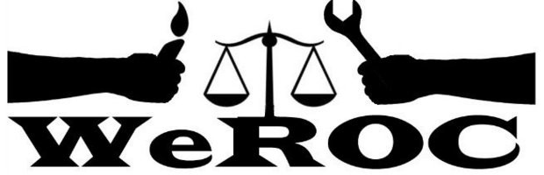
WeROC Meeting of the Whole
Via Zoom
Thursday April 7, 2022
Formal Meeting 5:30-6:30
Fellowship 6:30-7:00

Meeting Facilitator: Cindy Bodewes

5:30 Opening Prayer/Meditation

5:35 Agenda Review Cindy

5:40 Brief Introductions (Name, affiliation)

5:45 Friendraising Update and discussion Cindy & FR Team
WeROC Month
In Person Event/possible date/ theme/location
Congregational Organizing Jeff Harrold

6:00 MOSES Faith/Electoral Captain’s Academy
6:10 Report Outs from Action Teams
Justice Matters Tad/Alyshia
Voting Rights Jeff/Rita
Health Equity Cindy

6:25 Evaluation
Reflection
Formal Adjourn

6:30-7:00 Fellowship and/or Extended Conversation

Next Meetings
Meetings of the Whole
May 5
June 9
July 7

Our Mission
WeROC brings together faith, labor, community organizations and individuals to build healthy collective power needed to break down the systems that sustain injustice, racism, and economic inequality.

Our Vision
WeROC's vision is to use our organizing process for the purpose of creating opportunities for more people of color, lower income residents, and youth to participate at the tables where decisions affecting them and the broader community are made, so that together we are developing effective strategies for dismantling the structures that stubbornly maintain injustice, racism, and economic inequality in our area.

