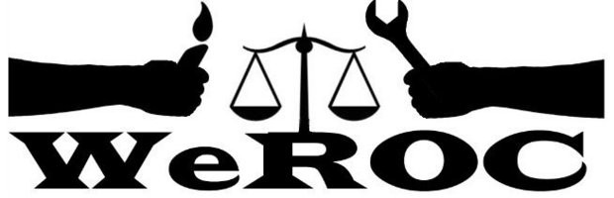

WeROC Meeting of the Whole
Via Zoom Thursday, October 6, 2022
Formal Meeting 5:30-6:30
Fellowship 6:30-7:00

Meeting Facilitator: Cindy Bodewes

5:30 Opening Reflection

5:35 Agenda Review Cindy

5:40 Brief Introductions (Name, affiliation)

5:45 Launching Membership Dues Cindy/Officers

6:00 Meetings in Person when and where? All

6:15 Training and Deep Canvassing with LEO Tad

6:20 Voter Rights Update

6:25 JMAT Update

6:30 Evaluation and adjourn formal meeting

6:30-7:00 Fellowship and/or Extended Conversation if needed
Next Meetings
November 3
December 1
January 5

Our Mission
WeROC brings together faith, labor, community organizations and individuals to build healthy collective power needed to break down the systems that sustain injustice, racism, and economic inequality.

Our Vision
WeROC's vision is to use our organizing process for the purpose of creating opportunities for more people of color, lower income residents, and youth to participate at the tables where decisions affecting them and the broader community are made, so that together we are developing effective strategies for dismantling the structures that stubbornly maintain injustice, racism, and economic inequality in our area.

