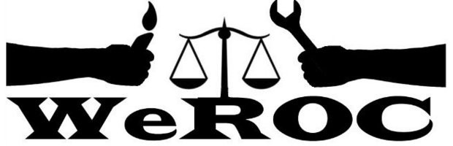

WeROC Meeting of the Whole
Thursday, February 2, 2023
5:30-6:30
6:30-7:00 extension if needed
Via Zoom

https://us02web.zoom.us/meeting/register/tZ0ud-2urz4jH9xL0PtNQesdLuWzRO7XZv0e.

Meeting Facilitator: Cindy Bodewes

5:30 Welcome and Opening Reflection Pastor Liz Larivee

5:35 Agenda Review Cindy Bodewes

5:40 Brief Introductions (Name, affiliation)

5:45 Forming a Nominating Committee Cindy Bodewes

6:00 Community Center in Superior Township Tad Wysor
- Organizing Around Community Center Issues

6:15 Follow up to Last Month CEJA Video Visioning Next Steps for WeROC Cindy and ALL

6:30-7:00 Fellowship and/or Extended Conversation if needed/desired
Next Meetings
March 2
April 6
May 4

Our Mission
WeROC brings together faith, labor, community organizations and individuals to build healthy collective power needed to break down the systems that sustain injustice, racism, and economic inequality.

Our Vision
WeROC's vision is to use our organizing process for the purpose of creating opportunities for more people of color, lower income residents, and youth to participate at the tables where decisions affecting them and the broader community are made, so that together we are developing effective strategies for dismantling the structures that stubbornly maintain injustice, racism, and economic inequality in our area.

