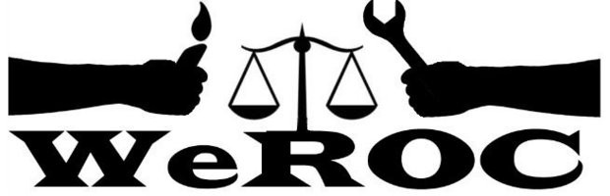

WeROC Meeting of the Whole
Thursday, March, 2023
5:30-6:30
6:30-7:00 extension if needed
In Person: 111 S. Wallace, Ypsilanti, MI 48197 or
Via Zoom https://us02web.zoom.us/j/7643282234

Meeting Facilitator: Cindy Bodewes

5:30 Welcome and Opening Reflection Cindy Bodewes

5:35 Agenda Review Cindy Bodewes

5:40 Brief Introductions (Name, affiliation)/New Participants

5:45 Nominating Committee Formed Cindy Bodewes

5:55 Community Center in Superior Township Tad Wysor/Cindy Bodewes

- How Can WeROC Help/Request from Pastor Wimberly

6:05 Report on a Day with Union Partners Cindy Bodewes/Tad Wysor

6:15 Action Team Updates
- Justice Matters
- Voter Rights
- Health Equity

6:25 MOSES Organizing 101 Training March 18 in Dearborn

6:30-7:00 Fellowship and/or Extended Conversation if needed/desired
Next Meetings
April 6
May 4
June 1

Our Mission
WeROC brings together faith, labor, community organizations and individuals to build healthy collective power needed to break down the systems that sustain injustice, racism, and economic inequality.

Our Vision
WeROC's vision is to use our organizing process for the purpose of creating opportunities for more people of color, lower income residents, and youth to participate at the tables where decisions affecting them and the broader community are made, so that together we are developing effective strategies for dismantling the structures that stubbornly maintain injustice, racism, and economic inequality in our area.

