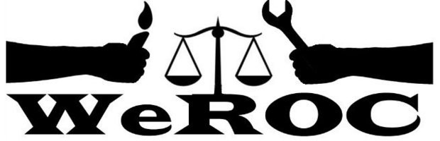

WeROC Meeting of the Whole
Thursday, February 1, 2024
5:30-7:00
This Month’s Meeting is All Virtual

Meeting Facilitator: Cindy Bodewes

5:30 Welcome and Opening Reflection

5:35 Agenda Review Cindy Bodewes

5:40 Brief Introductions (Name, affiliation)/New Participants

5:45 Organizing 101 Training March 9 Cindy/DeJuan

5:50 Update on Mental Health Millage Conversation Cindy Bodewes

6:00 JMAT Juvenile Justice Campaign

6:10 Voter Rights and Access Update Jeff/Rita

6:20 Request from ICPJ Judy

Next Meetings

Our Mission
WeROC brings together faith, labor, community organizations and individuals to build healthy collective power needed to break down the systems that sustain injustice, racism, and economic inequality.

Our Vision
WeROC's vision is to use our organizing process for the purpose of creating opportunities for more people of color, lower income residents, and youth to participate at the tables where decisions affecting them and the broader community are made, so that together we are developing effective strategies for dismantling the structures that stubbornly maintain injustice, racism, and economic inequality in our area.

