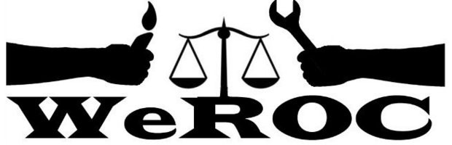

WeROC Meeting of the Whole
Thursday, April 4, 2024
5:30-6:30
6:30-7:00 extension if needed
This Month’s Meeting is ALL VIRTUAL

Meeting Facilitator: Cindy Bodewes

5:30 Welcome and Opening Reflection

5:35 Agenda Review Cindy Bodewes

5:40 Brief Introductions (Name, affiliation)/New Participants

5:45 Update on Mental Health Millage, Commissioners Meeting and Mental Health Forums

6:05 Update on Justice Matters Juvenile Justice Campaign, Washtenaw, Wayne and Oakland
Counties

6:15 Update on Voter Rights and Access Action Team

6:25 Evaluation and Adjourn

6:30-7:00 Extended conversation if needed

Next Meetings
May 2
June 6
July 11

Our Mission
WeROC brings together faith, labor, community organizations and individuals to build healthy collective power needed to break down the systems that sustain injustice, racism, and economic inequality.

Our Vision
WeROC's vision is to use our organizing process for the purpose of creating opportunities for more people of color, lower income residents, and youth to participate at the tables where decisions affecting them and the broader community are made, so that together we are developing effective strategies for dismantling the structures that stubbornly maintain injustice, racism, and economic inequality in our area.

